**Assignment 2: Produce a comparative infographic of TDD, BDD, and FDD methodologies. Illustrate their unique approaches, benefits, and suitability for different software development contexts. Use visuals to enhance understanding.**

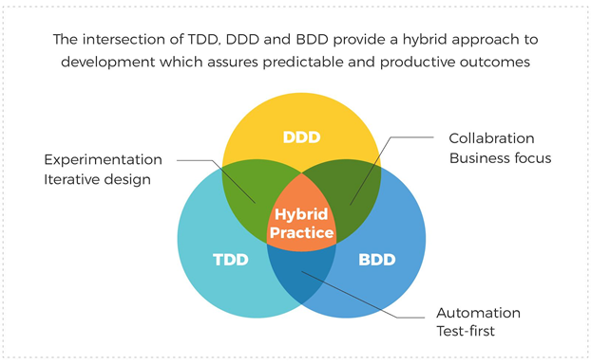

**1. Test-Driven Development (TDD):**

Visual representation of TDD process (similar to the previous infographic).

Key points:

Approach: Writing tests before writing code.

Benefits: Bug reduction, improved code quality, faster development.

Suitability: Ideal for projects with well-defined requirements and where code quality and reliability are paramount.

**2. Behavior-Driven Development (BDD):**

Illustration showing the collaboration between developers, QA, and stakeholders.

Key points:

Approach: Focuses on behavior and interactions of the system from an end-user perspective.

Benefits: Enhanced communication between stakeholders, improved understanding of requirements.

Suitability: Suitable for projects with complex business logic and where collaboration between stakeholders is crucial.

**3. Feature-Driven Development (FDD):**

Visual depiction of FDD's feature-centric approach.

Key points:

Approach: Development organized around features and client-valued functionality.

Benefits: Clear visibility of project progress, iterative development, early identification of issues.

Suitability: Well-suited for large-scale projects with multiple teams, where features can be independently developed and integrated.

Comparative Analysis:

Visual representation of a table or chart comparing TDD, BDD, and FDD across various factors like approach, benefits, suitability, etc.

**Conclusion:**

Summary statement highlighting that the choice of methodology depends on project requirements, team dynamics, and stakeholder involvement.